Installation Manual: Strategic Relationship Audit
Nov 1, 2026 · @Siripod

1. What you will deploy
This manual installs the Strategic Relationship Audit with Netlify hosting the website and Neon hosting the PostgreSQL database. Both have free plans, and the live site at strategic-relationship.netlify.app runs this way. Setup takes about 30 minutes and needs no software on your computer.
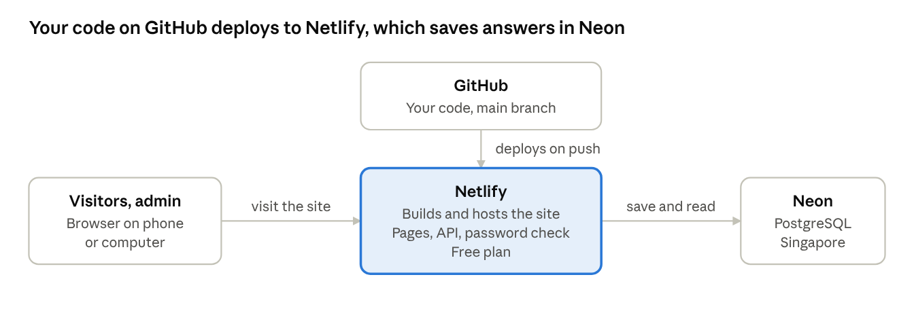
Deployment overview · GitHub, Netlify, Neon
When you push code to GitHub, Netlify builds and publishes the site. Visitors use the site on Netlify, which saves each completed quiz to Neon.

What you need
Item | Details
GitHub account | Holds the code; Netlify deploys from it
Neon account | Free plan; hosts the database
Netlify account | Free plan; hosts the website
A web browser | Nothing else to install
Time | About 30 minutes

Free plan limits
The limits below were read from the providers' pages in November 2026 and can change.
Service | Free plan | What to watch
Netlify | 300 credits | A production deploy costs 15 credits, and traffic uses the same credits. The pricing page does not say what happens at the limit
Neon | 1 GB storage and 100 compute hours per project each month; no credit card | The database suspends after 5 minutes without use, so the first request afterwards is slower
Check Netlify's terms on commercial use before promoting a site that sells courses.

About the menu drawings
Most steps use a drawing of the menu path, so colours and layout on your screen will differ. The Netlify steps for variables and deploys also show real screenshots, taken from the signed-in console with secret values hidden. Button and menu names were checked against Neon's and Netlify's documentation in November 2026; if a name has changed, look for the closest match.

2. Before you start

Put the code in GitHub
Netlify deploys from a GitHub repository. The live site uses the private repository siripods/relationship-audit.
- Sign in to GitHub and create a private repository for the project, unless you already have one.
- Upload the project's files to it. From a computer that has the project folder and Git installed, run these commands with your own repository address:
git remote add origin https://github.com/YOUR-NAME/relationship-audit.git

git push -u origin main
- Check that the repository does not contain a file named .env. It holds secrets, and the project's .gitignore keeps it out.

Prepare these values
Item | What to prepare | Used in
Admin password | A long, unique password. Thai characters and colons work. Keep it in a password manager | ADMIN_PASSWORD in Netlify, Step 3
Region | The one closest to your visitors. Singapore suits visitors in Thailand | Neon, Step 1
Database connection string | Created in Step 1. It contains the database password | DATABASE_URL in Netlify, Step 3

Keep secrets safe
- Never paste a password or connection string into GitHub, chat, email or this document.
- If either one is exposed, change it at its source (Neon or Netlify) and deploy again.
- Use a different admin password for any test or UAT copy of the site.

3. Step 1: Create the database on Neon
Neon hosts the PostgreSQL database. You create the project and copy one connection string; you do not need to create any tables yourself.
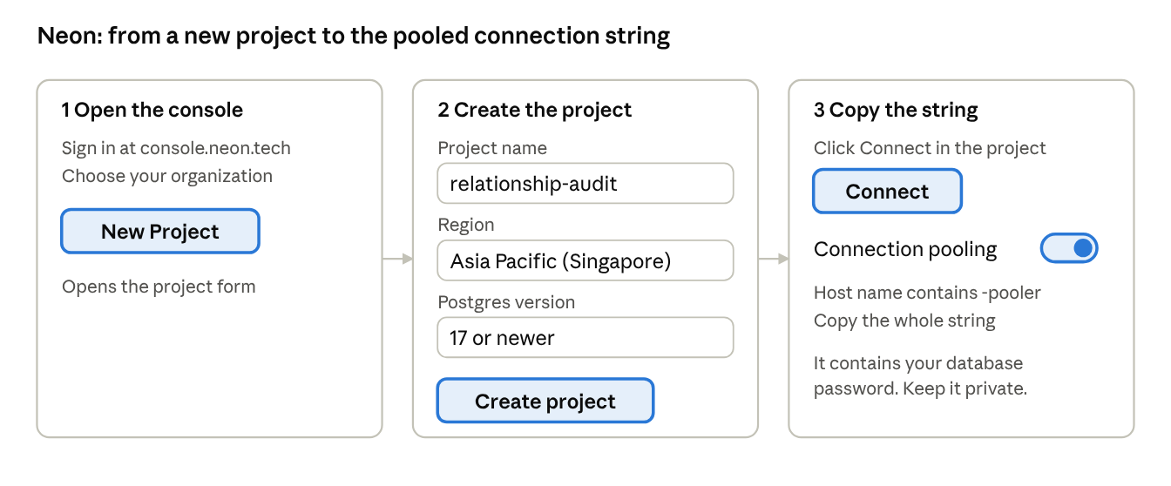
Neon menu path · 3 steps
- Sign in at console.neon.tech. If you belong to several organizations, choose the one that should own the database.
- Click New Project.
- Enter a Project name, for example relationship-audit.
- Choose a Region close to your visitors. The live site uses Singapore (aws-ap-southeast-1).
- Under Services, keep Postgres database on. Expand it to choose the Postgres version. The app needs version 13 or newer and was tested on 17.5 and 18.6.
- Click Create project. The project's Overview page opens.
- Click Connect in the console navigation. In the Connect to your branch dialog, keep the default branch, database and role, and make sure Connection pooling is on.
- Copy the connection string. A pooled string has -pooler in its host name, between the endpoint ID and the region domain.
Keep the string somewhere private until Step 3. The site runs as short-lived serverless functions, so it needs the pooled string; the direct string can run out of connections.
The table that stores quiz answers is created automatically by the first production build in Step 2, so there is nothing else to set up in Neon.

4. Step 2: Create the project on Netlify
Netlify builds the app from GitHub and hosts it. The build settings are already in the repository's netlify.toml, so you only connect the repository.
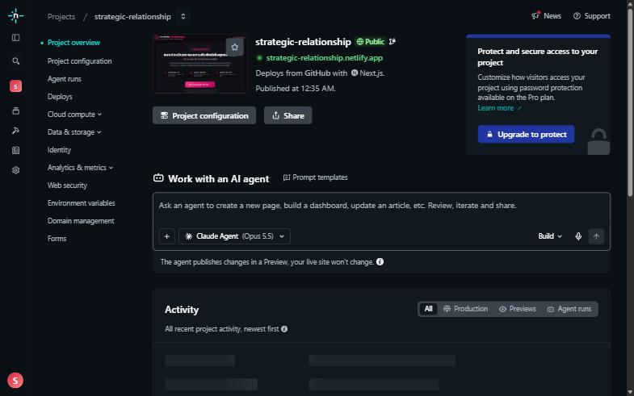
The project overview after the first deploy. The left menu has Deploys, Project configuration, Environment variables and Domain management.
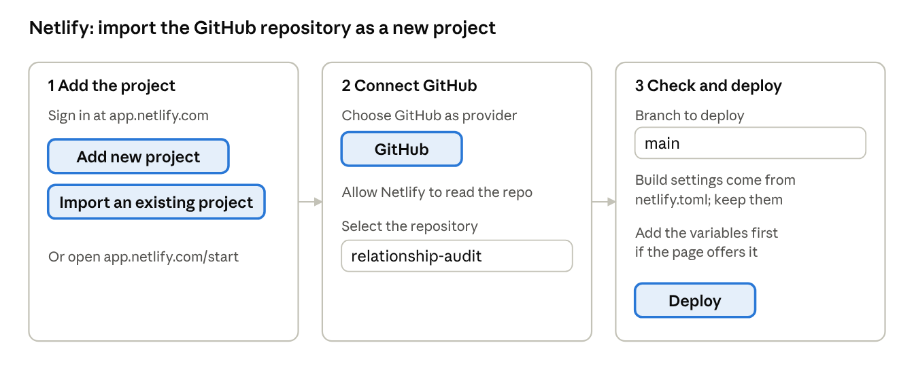
Netlify menu path · import a project
- Sign in at app.netlify.com. Signing in with your GitHub account is the simplest.
- Choose Add new project, then Import an existing project. You can also open app.netlify.com/start directly.
- Choose GitHub. When asked, allow Netlify to read the repository. You can limit access to just this repository.
- Select the repository, for example relationship-audit, and the branch main.
- Keep the build settings, which come from netlify.toml.
- If the setup page has an Environment variables section before the deploy button, add the two variables from Step 3 now. If it does not, continue. The first deploy will then fail at the database step because the variables are missing. That is expected: add them in Step 3 and deploy again.

What netlify.toml sets
Setting | Value | Why
Build command, all deploys | npm run build | Builds the Next.js app
Build command, production only | npm run db:migrate && npm run build | Creates the responses and settings tables, and adds the three course rows, before the build. It never overwrites course text you have edited, and it is safe to repeat
NODE_VERSION | 22 | The Node.js version used for builds
Deploy previews and branch deploys do not change the database, because only production builds run db:migrate.

5. Step 3: Add the environment variables
The site reads two environment variables. They are stored only in Netlify and never in GitHub.
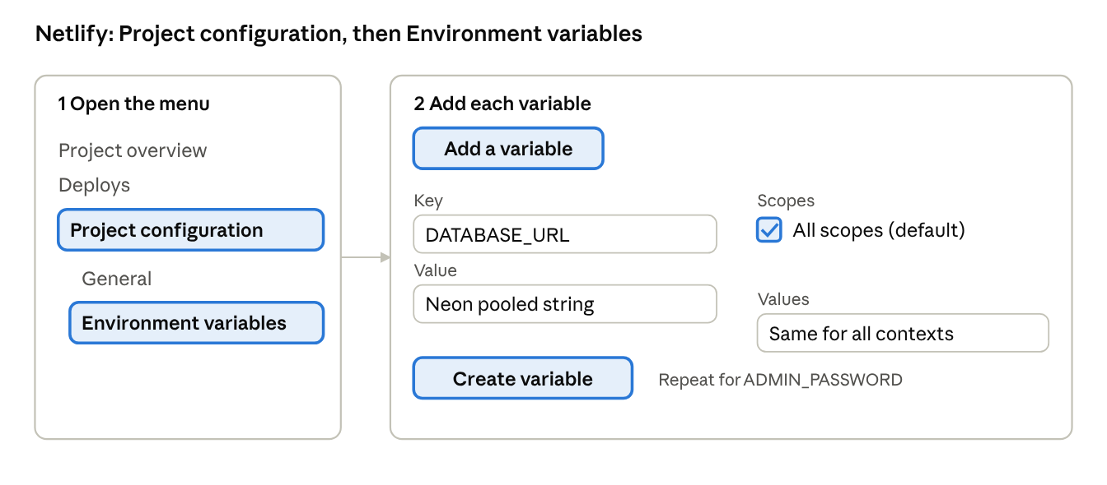
Netlify menu path · environment variables
Key | Value | Notes
DATABASE_URL | The Neon pooled connection string from Step 1 | Used during the build, to create the table, and while the site runs
ADMIN_PASSWORD | Your admin password | Protects /admin and /backoffice. The username is always admin
MAINTENANCE_MODE (optional) | on, only while you want the site closed | Do not add it now. Section 8 explains how to close and reopen the site
- In your Netlify project, open Project configuration, then Environment variables.
- Choose Add a variable and add each key from the table, one at a time.
- Keep Scopes on All scopes, the default. On the free plan, choosing specific scopes needs an upgrade. The build needs DATABASE_URL to create the tables, and the password check runs as a function.
- Give each variable a value for Production, or for All deploy contexts.
- If the form offers to mark the value as secret, turn that on.
- Save each variable, then deploy again, as described in Step 4.
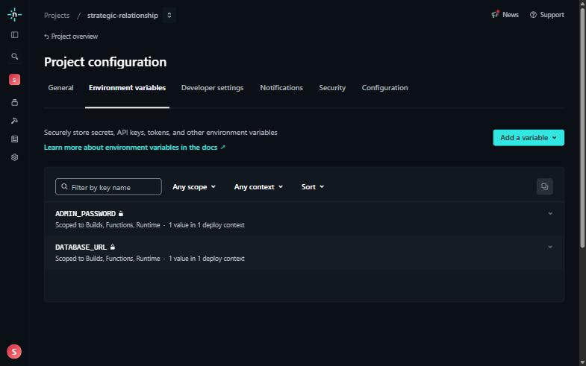
Project configuration, Environment variables. Your two variables appear by name, and their values stay hidden.
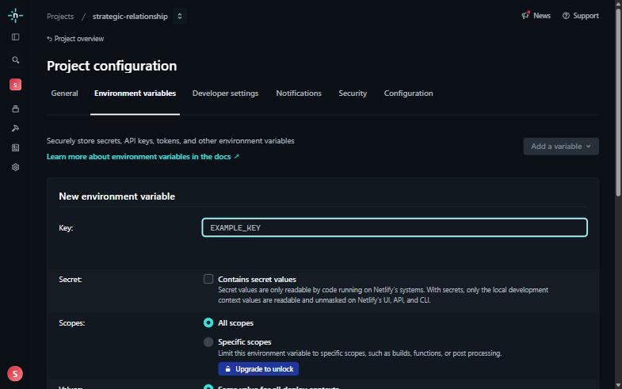
Add a variable, then Add a single variable. Type the name in the Key box. All scopes is already selected.
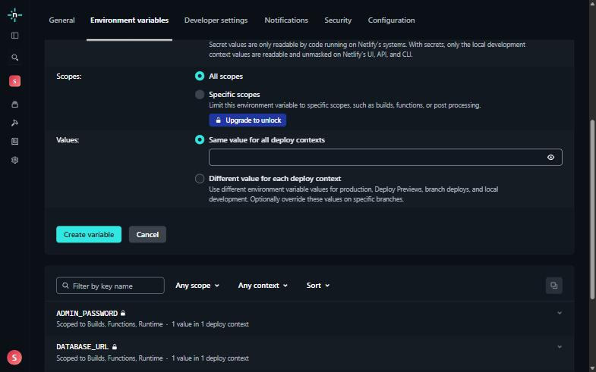
Type the value under Same value for all deploy contexts, then press Create variable.
Changes to environment variables only take effect after a new deploy. Do not put either value in netlify.toml: that file is stored in Git, and Netlify does not pass its variables to edge functions.

6. Step 4: Deploy and make the site public
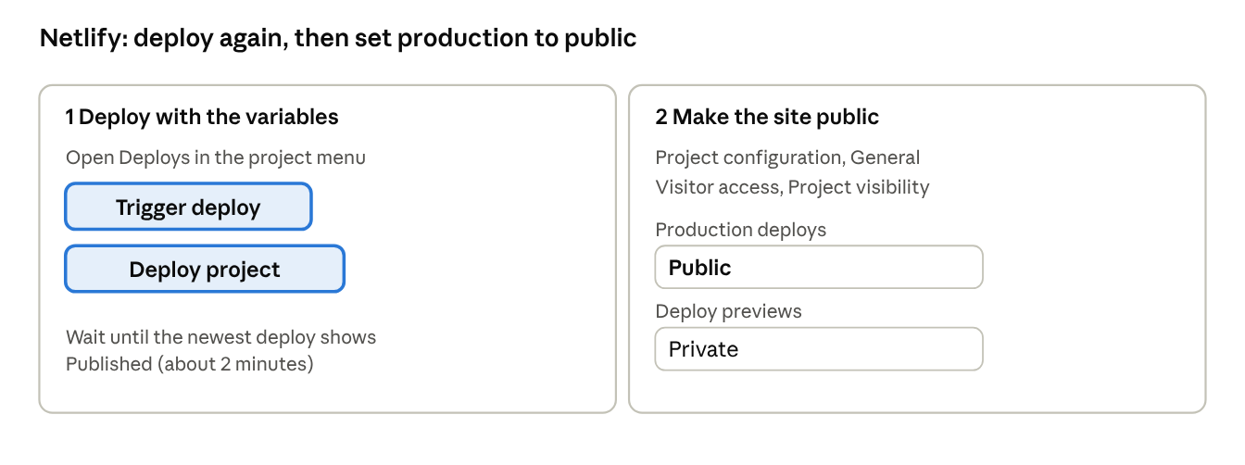
Netlify menu path · deploy and visibility

Deploy
- Open Deploys in the project.
- Choose Trigger deploy, then deploy the project. Older screens say Deploy site. Skip this step if you added both variables before the first deploy and it succeeded.
- Open the newest deploy to watch its log. The production build first runs db:migrate, which prints Schema is up to date., and then builds the app. It takes about two minutes.
- Wait for the status Published.
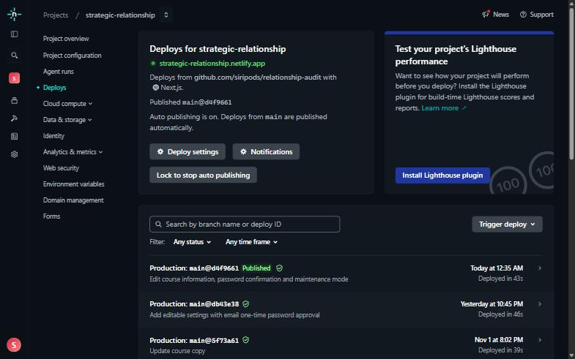
The Deploys page. The newest deploy is marked Published. Trigger deploy is on the right, and Lock to stop auto publishing is under the project details.
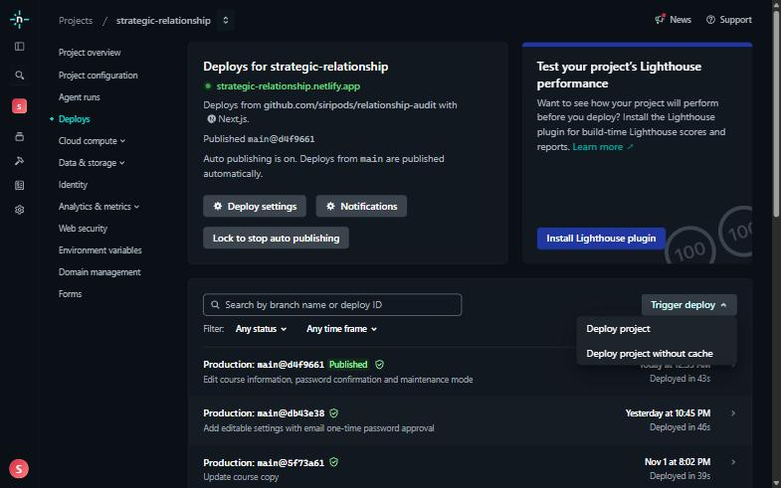
The Trigger deploy menu. Choose Deploy project.

Make the site public
Netlify can start new projects as private. Every visitor is then sent to a Netlify sign-in page that says the site is private.
- Test the site first while you are signed in to Netlify.
- Go to Project configuration, then General, then Visitor access, then Project visibility.
- Set production deploys to public, and keep deploy previews private.
Public means anyone with the address can open the quiz. Do this only when you are ready for visitors.

7. Step 5: Verify the installation
The installation is complete when every check below passes. Use your own address in place of your-site.netlify.app.
- ☐ The address shows the intro page, and the start button opens question 1.
- ☐ Answering all 10 questions shows a report. This saves a real response.
- ☐ Choosing the most severe answer on question 1 shows helplines and no courses.
- ☐ /backoffice asks for a login and accepts admin with your password.
- ☐ The backoffice report counts your test responses, /backoffice/charts shows the pie charts, and /backoffice/usage shows today's count.
- ☐ /backoffice/settings shows the LINE link and the three courses, each with a saved time. This proves the deploy added the course rows to the database.
- ☐ Saving a change on that page asks for the admin password again, and refuses a wrong one.
- ☐ In a private window, cancelling the login at /backoffice refuses access.

Quick checks that save nothing
This should print 401, which proves the backoffice is locked:
curl -s -o /dev/null -w "%{http_code}\n" https://your-site.netlify.app/backoffice
This should print 404. The page looks up a report that does not exist, which proves the site can reach the database:
curl -s -o /dev/null -w "%{http_code}\n" https://your-site.netlify.app/results/00000000-0000-0000-0000-000000000000

Before real visitors arrive
Delete your test responses so they do not appear in the statistics. In Neon, open the project, choose SQL Editor, and run the command below. It removes every response, so run it only before launch.
DELETE FROM responses;

8. Day-to-day operations

Update the site
Push your changes to the main branch on GitHub. Netlify builds and publishes the new version automatically.
- Each production deploy uses 15 of the free plan's 300 credits, so group changes into fewer pushes.
- For a commit that only changes documents, put [skip netlify] in the commit message. Netlify should then skip the deploy. Check the Deploys page the first time you use it.

Roll back a bad deploy
Open Deploys, open an earlier deploy that was published successfully, and choose the option to publish it. Netlify's Manage deploys documentation describes the current steps. Rolling back changes the website only; it does not undo changes to the database.
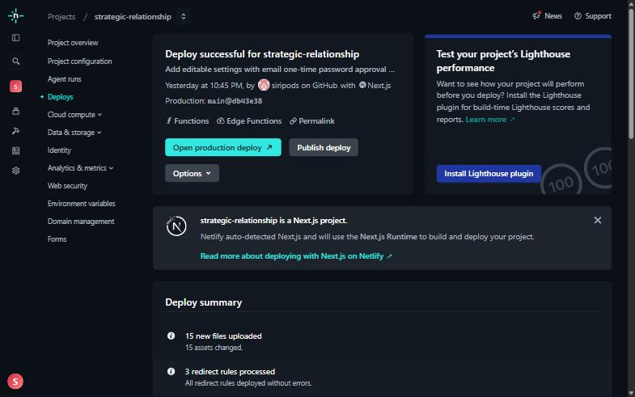
An older, successful deploy. Press Publish deploy to put that version back on the live site. Do not press it unless you mean to replace the live site.

Change the admin password
- Open Project configuration, then Environment variables, and edit ADMIN_PASSWORD.
- Save it, then choose Trigger deploy under Deploys.
- After the deploy is published, the old password stops working. Log in again in a private window.

Change the database password
In Neon, reset the database role's password, copy the new pooled connection string from the Connect dialog, update DATABASE_URL in Netlify, and deploy again.

Keep a copy of your data
This manual did not check the backup and restore options of Neon's free plan, so keep your own copy of the responses. From a computer with the PostgreSQL client tools installed, run this with Neon's direct connection string, which you get by turning Connection pooling off in the Connect dialog:
pg_dump "YOUR-DIRECT-CONNECTION-STRING" --table=responses --data-only --file=responses-backup.sql
The backup file contains sensitive answers, so store it securely.

Watch the free plan
Check your Netlify credit usage before and after a marketing campaign, since traffic uses the same credits as deploys. Check Neon's storage and compute usage in its console in the same way.

Edit the LINE link and course text
These are changed in the backoffice, with no deploy and no code change.
- Open /backoffice, then the Settings page (ตั้งค่า).
- Change the LINE link, or press Edit beside a course and change its fields.
- Type the admin password again and press Save.
- Visitors see the change at once, or within a few minutes.
The System Administration Manual describes every field and its limit.

Close the site for maintenance
Netlify has no server to stop, so the site has its own switch. While it is on, every public page shows a Thai page that says the system is closed for a while and lists the helplines. Saving a quiz is refused. The backoffice keeps working.
- In Netlify, open the project, then Project configuration, then Environment variables.
- Press Add a variable, then Add a single variable. Type MAINTENANCE_MODE as the key and on as the value, keep All scopes, and press Create variable.
- Open Deploys, choose Trigger deploy, then Deploy project, and wait until it shows Published.
- To reopen, delete the variable, deploy again, and repeat the checks in Step 5.
Each change is a deploy and uses 15 credits.

9. Troubleshooting
For a failed build, open Deploys, open the failed deploy and read the build log. The first error line usually names the cause.
Symptom | Likely cause | Fix
Every page redirects to a Netlify sign-in that says the site is private | The project's visibility is private | Step 4: set production deploys to public
The build fails at db:migrate with "DATABASE_URL is not set" | The variable is missing, or its scopes do not include Builds | Step 3, then deploy again
The build fails at db:migrate with a connection or password error | The string was copied incompletely, or the database password changed | Copy the pooled string again from Neon's Connect dialog, update DATABASE_URL, and deploy again
The quiz says it cannot send the answers | The database could not be reached, or Neon was waking up | Wait a few seconds and retry. Then check DATABASE_URL and the function logs in Netlify
/backoffice shows "ADMIN_PASSWORD is not set for this deployment" (503) | The variable is missing, or it was changed without a new deploy | Step 3, then deploy again
/backoffice always refuses your password | Wrong username or password, an old password remembered by the browser, or a change that was not deployed | Use the username admin, try a private window, and deploy again after any change
The first save after a quiet period is slow | Neon suspended the database after 5 minutes without use | Expected on the free plan; the next requests are fast
A change you pushed does not appear | The deploy is still running, failed, or was skipped by [skip netlify] | Check Deploys
An error page appears after a deploy | The deploy has a fault | Read the deploy log, then roll back to the last good deploy

10. Reference

Environment variables
Variable | Required | Purpose
DATABASE_URL | Yes | Neon pooled connection string, used by the build and by the running site
ADMIN_PASSWORD | Yes | Password for /admin and /backoffice; the username is admin
NODE_VERSION | Set by netlify.toml | Node.js version for builds, 22
MAINTENANCE_MODE | No | Set to on to close the public site with a Thai maintenance page. The backoffice stays reachable. Leave it out for normal operation

Files that control deployment
File | Purpose
netlify.toml | Build command, Node version, and db:migrate on production builds only
db/schema.sql | The responses and settings tables, applied by db:migrate; safe to run repeatedly
package.json | The build and db:migrate scripts
.env.example | Template for a local .env; Netlify does not read it
next.config.mjs | Security headers (Content-Security-Policy, no framing, no referrer) and the image optimizer setting
middleware.ts | The backoffice login, and maintenance mode for the public site

Links
- Neon console and Netlify
- Neon: create a project and connection pooling
- Netlify: environment variables and edge function variables
- Netlify: project visibility
- Netlify pricing and Neon pricing

About this version
This version covers Netlify and Neon only. It replaces the earlier version of the manual, which described installing on an Ubuntu server; that version remains in this document's version history.
For everyday running of the site, including shutdown and maintenance mode, see the System Administration Manual.

